What’s on this week
Sun 27th Nov - 11.45 am CHURCH AGM

Mon 28th Nov - 7.30 pm Home Group @ Reuben’s

Tue 29th Nov - 6.30 pm Bible School @ Church
- 7.00 pm BSF @ Church

Thu 1st Dec - 6.30 pm Music practice @ Church

Fri 2nd Dec - 6.00 pm AWANA @ Church

Sun 4th Dec - 10.00 am SERVICE

Sat 10th Dec - 5.00 pm Dinner & Games night @ Church

Ministry Reminders
Date | Preaching | Sunday School | Welcoming | Morning Tea
27th Nov | Ps Greg | Paw/Hannah | BIll | None
4th Dec | Andrew B | Wilma/Kaida | Peter | Nau
11th Dec | Ps Greg | In recess | Gilly | Reuben
18th Dec | Charlie Cain | In recess | Bill
25th Dec | Ps Greg | In recess | Wendy

2022 No.36  27/11/22 | Good morning and welcome to the Kelmscott Baptist Church. It’s great to have you with us and we hope you’ll be encouraged as you join us in worship.  Serving an Incredibly Generous God  Our God is incredibly generous. He is a Rewarder (Hebrews 11:6). He is a God of love (1 John 4:8), meaning he desires and works for the good of others (1 Corinthians 13:4-7). God has demonstrated this love and this generosity in the greatest possible way, by sending his Son to die for our sins (Romans 5:8). How then should we, his children, those who have benefited immensely from his love, serve such a God? The answer, with extravagant generosity.  This was the Apostle Paul’s argument when he was encouraging the Corinthians to give generously to God’s work in 2 Corinthians chapters 8 & 9. Here is a very brief overview of those chapters:  Big Idea: Excel in your giving (2 Cor 8:7).  A. Christ, who was rich, became poor for your sakes as an example of amazing, self-sacrificial giving (2 Cor 8:9)  B. So give: willingly (8:11), proportional to your income (8:12), to bless others (8:13-15), generously (9:5-6), cheerfully (9:7), for eternity (9:9), having faith God will provide your needs (9:10-11), in thankfulness (9:12), for God’s glory (9:13)  A’ God sent his Son for us, as an example of amazing, self-sacrificial giving (2 Cor 9:15)  Let’s serve our God here at KBC with generosity.  Pastor Greg
Glory to God
Hope to the World

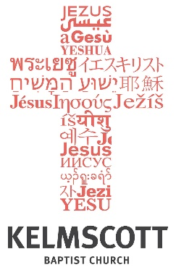

Pastor
Greg Burgess
0406742009

We meet at
10.00 am Sunday
29 Third Ave
Kelmscott WA 6111

Website
www.kelmscottbaptist.org.au.o
rg.au

The Art & Joy of Giving
1 Corinthians 16

Introduction

Three local church priorities we must have to further the cause of the Gospel

- Let us ___________________________________________________

- Let us ___________________________________________________

- Let us ___________________________________________________

Big Idea:

